SUNDAY | MONDAY | TUESDAY | WEDNESDAY | THURSDAY | FRIDAY | SATURDAY
31 4th in LENT  9:00am Senior Choir  10:00am Coffee, Tea and  Conversation  10:30am Worship and  Sunday School  11:45am Ways and Means  Grocery Card Fundraiser | 1  1:30pm Unit 7  in the Church Library  4:30pm/5:30pm/6:30pm  3rd Bridgewater Scouting  Fundraiser at Pizza Delight  6:30pm Scouts  6:30pm Wee Wisdom  Nursery School  Committee | 2 | 3  6:30pm Beavers  7:00pm Senior Choir  7:00pm Faith Formation  Committee | 4  9:30am Lenten Study  11:30am – 1:00pm Lenten  Soup Luncheon at Holy Trinity Anglican Church hosted by Bridgewater Baptist and The Salvation Army Church  6:00pm- 7:30pm  47th Annual Bridgewater Music Festival  No Access to Sanctuary  6:30pm Cubs | 5  9:00am – 8:15pm  47th Annual Bridgewater Music Festival  No Access to Sanctuary | 6  9:00am – 8:30pm  47th Annual Bridgewater Music Festival  No Access to Sanctuary
7 5th in LENT  FOOD BANK SUNDAY  9:00am Senior Choir  10:00am Coffee, Tea and  Conversation  10:30am Worship and  Sunday School  1:30pm – 8:00pm  47th Annual Bridgewater  Music Festival  No Access to Sanctuary | 8  9:00am – 5:30pm  47th Annual Bridgewater Music Festival  No Access to Sanctuary  6:30pm Scouts  7:00pm UCW  7:00pm Men’s Choir | 9  5:30pm Floor Maintenance | 10  4:30pm/5:30pm/6:30pm  B.U.C Brigade Mission Trip  Fundraiser at Pizza Delight  5:00pm Worship Committee  6:30pm Beavers  7:00pm Senior Choir  7:00pm Nominating  Committee  7:00pm Ministry and  Personnel Committee | 11  9:30am Lenten Study  11:30am – 1:00pm Lenten  Soup Luncheon at Holy Trinity Anglican Church hosted by Bridgewater United and Lighthouse Community Church  6:30pm Cubs  7:00pm Property  Committee | 12 | 13  “To really change the world, we have to help people change the way they see things.” ~ Suzy Kassem
14 PALM SUNDAY  MEMBERSHIP SUNDAY  9:00am Senior Choir  10:00am Coffee, Tea and  Conversation  10:30am Worship and  Sunday School  11:30am Welcoming Reception | 15  6:30pm Scouts | 16  10:00am Pastoral Care  Committee  4:30pm Bridgewater  Day Care Committee | 17  6:30pm Beavers  7:00pm Senior Choir | 18 MAUNDY  THURSDAY  6:30pm Cubs  7:00pm Worship  with Holy Communion | 19 GOOD FRIDAY  10:30am Worship  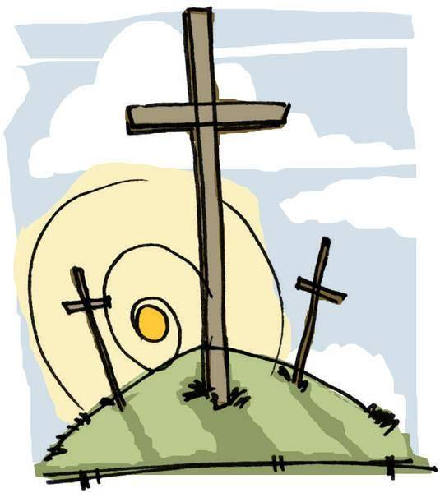  CHURCH OFFICE  CLOSED | 20
21 EASTER DAY  EARTH SUNDAY  9:00am Senior Choir  9:45am Easter Egg Hunt  10:00am Coffee, Tea and  Conversation  10:30am Worship with Holy  Communion and Children’s Activity Table | 22 EASTER MONDAY  6:30pm Scouts  CHURCH OFFICE  CLOSED | 23  5:30pm Floor Maintenance | 24  4:00pm Inclusivity  Committee  6:30pm Beavers  7:00pm Church Council  7:45pm 3rd Bridgewater  Scout Group Committee | 25  6:30pm Cubs  7:00pm Arts & Crafts | 26  6:30pm BUC  Youth Group  Grade 6 to Grade 12  All Are Welcome | 27  10:00am – 3:00pm  BUC Quilters  All Are Welcome
28 2nd OF EASTER  9:00am Senior Choir  10:00am Coffee, Tea and  Conversation  10:30am Worship and  Sunday School  11:30am UCW Cookie and  Muffin Sale for Starfish International | 29  6:30pm Scouts | 30 |  | Church Office Hours are Monday – Friday 9:30am – 1:00pm  Our Church is a Nut-Free and Scent-Free Church  Church Office Phone: (902) 543-4833  Ministers’ Shared Private Office Phone: (902) 543-6854  Reverend Jeff Chant: revjeffchant@gmail.com  Angela Clifton: aclifton@eastlink.ca (902) 527-2739  Church Office E-mail: buc@tallships.ca Website: www.bridgewaterunited.ca Facebook: https://www.facebook.com/BridgewaterUnitedChurch?ref=hl

BRIDGEWATER UNITED CHURCH APRIL 2019

Holy Week and Easter Services

April 14th – Palm Sunday and Membership Sunday
10:00am Coffee, Tea and Conversation
10:30am Worship and Sunday School
“Jesus' triumphant entry into Jerusalem”
11:30am Welcoming Reception

April 18th - Maundy Thursday
7:00pm Worship Service with Holy Communion
“The Last Supper”

April 19th - Good Friday
Church Office Closed
10:30am Worship Service
“The crucifixion of Jesus and his death at Calvary”

April 21st – Resurrection Sunday: Easter Day
9:45am Easter Egg Hunt in the Sanctuary
10:00am Coffee, Tea and Conversation
10:30am Worship Service with Holy Communion
“The resurrection of Jesus from the dead”

April 22nd – Easter Monday
Church Office Closed

