Be United Communities of Faith
Bridgewater United Church West Side United Church
March 28th, 2024 Maundy Thursday
Ministry Team: Reverend Neil McEwen and Reverend Hans van Nie
West Side United Student Minister: Donna Kelly

Greeter: Jack Logan Greeter: Jane Martin

The asterisk (*) indicates the congregation may stand, as they are able.
The print in BOLD is where the congregation participates.

Welcome and Introduction

Invitation to Worship:
Jesus said: “This is my commandment, love one another.”
We gather in worship to seek the way of love.
Jesus said: “Follow me.”
We gather in worship to walk in the way of discipleship.
Jesus said: “I am the way, the truth, and the life.”
We gather in worship to embrace the way of Christ.

Opening Prayer: (unison)
Holy God, we come to worship
in the gathering shadows of suffering and death.
We come with the friends of Jesus,
those who have followed Jesus in every place and generation,
to live once again this story of love and betrayal,
of weakness and courage.
We come to witness your love in action.
Be with us, we pray, in Jesus’ name. Amen.

Hymn: “Shadows Gather, Deep and Cold” (VU 134)
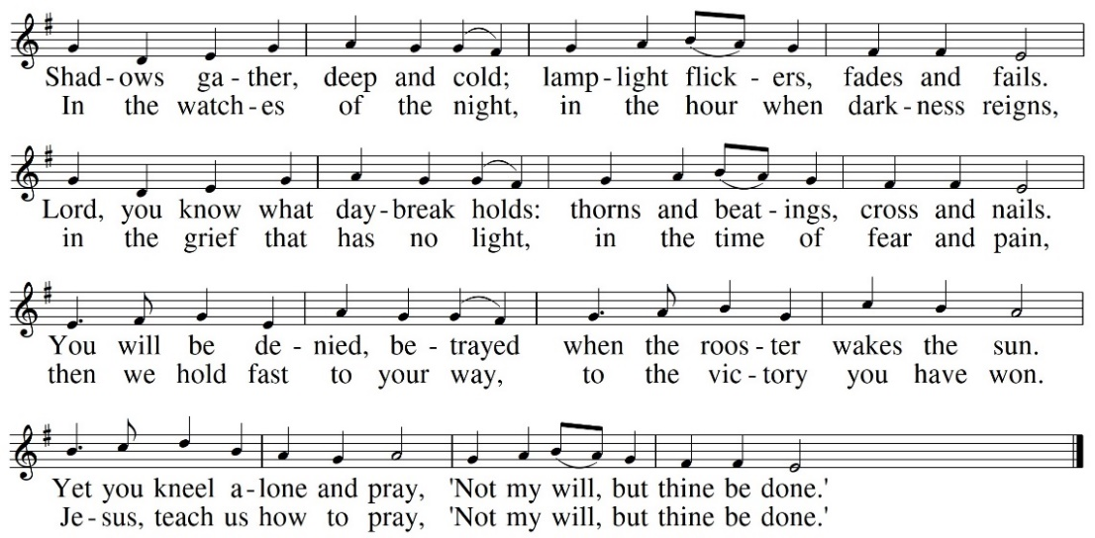

Prayer of Confession: (unison)
Examine us, O God, and know our hearts;
test and judge our thoughts.
Cleanse the deceit within us and guide us in the way of life.

~ silent confession ~

Assurance:
God asks of us a humble spirit;
God accepts a contrite heart.
God delivers us from death,
our eyes from tears, our feet from stumbling.
We walk with God in the land of the living.
Thanks be to God!

Foot-washing: (John 13, assorted verses)
Before the festival of the Passover, Jesus knew that his hour had come to depart from this world. Having loved his own who were in the world, he loved them to the end. Jesus got up from the table, took off his outer robe, and tied a towel around himself. Then he poured water into a basin and began to wash the disciples’ feet and to wipe them with the towel that was tied around him. He came to Simon Peter, who said to him, “Lord, you will never wash my feet.” Jesus answered, “Unless I wash you, you have no share with me.” After he had washed their feet, he said to them, “Do you know what I have done to you? You call me Teacher and Lord, and you are right, for that is what I am. So if I, your Lord and Teacher, have washed your feet, you also ought to wash one another’s feet. I give you a new commandment, that you love one another. Just as I have loved you, you also should love one another. By this everyone will know that you are my disciples, if you have love for one another.”

Hymn: “Ubi Caritas (Where There Is Charity)” (MV 170)

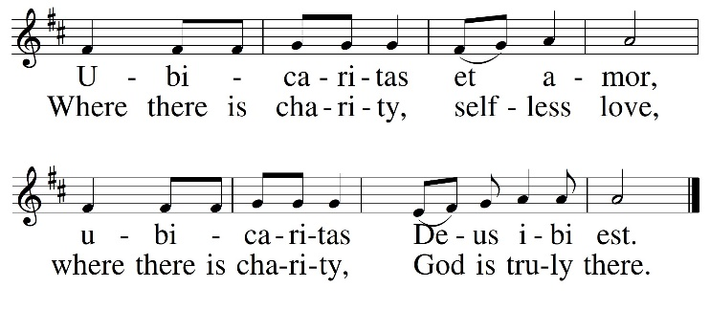
The Supper: (Mark 14:17-24)
When it was evening, they gathered for the Passover Supper. When they had taken their places and were eating, Jesus said, “Truly I tell you, one of you will betray me, one of you who is eating with me.” They began to be distressed and to say to him one after another, “Surely, not I?” He said to them, “It is indeed one of you." Then, while they were eating, Jesus took a loaf of bread, and after blessing it he broke it, gave it to them, and said, “Take; this is my body.” Then he took a cup, and after giving thanks he gave it to them, and all of them drank from it. Jesus said to them, “This is my blood of the covenant, which is poured out for many.

Sharing the Bread and Cup

The Garden of Gethsemane: (Mark 14:26-41)
They went out to the Mount of Olives. And Jesus said to them, “You will all fall away. Peter said to him, “Even though all fall away, I will not.” Jesus said to him, “Truly I tell you, this day, this very night, before the cock crows twice, you will deny me three times.” But Peter said vehemently, “Even though I must die with you, I will not deny you.” And all of them said the same. They went to a place called Gethsemane, and he said to his disciples, “Sit here while I pray.” Jesus began to be distressed and agitated. And he said to them, “My soul is deeply grieved, even to death; remain here, and keep awake.” And going a little farther, he threw himself on the ground and prayed that, if it were possible, the hour might pass from him. He prayed, “Abba, Father, for you all things are possible; remove this cup from me, yet not what I want but what you want.” Jesus came and found them sleeping, and he said to Peter, “Simon, are you asleep? Could you not keep awake one hour? Keep awake and pray that you may not come into the time of trial; the spirit indeed is willing, but the flesh is weak.” And again he went away and prayed, saying the same words. And once more he came and found them sleeping, for their eyes were very heavy, and they did not know what to say to him. He came a third time and said to them, “Are you still sleeping and taking your rest? Enough! The hour has come; the Son of Man is betrayed into the hands of sinners.

Hymn: “Stay With Me” (VU 950)

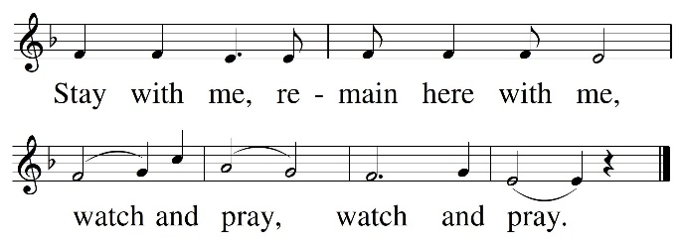

Arrest, Trial and Peter’s Denial: (Mark 14:43-72)
While Jesus was still speaking, Judas, one of the twelve, arrived, and with him there was a crowd with swords and clubs. The betrayer had given them a sign, saying, “The one I will kiss is the man; arrest him and lead him away under guard.” So when he came, he went up to him at once and said, “Rabbi!” and kissed him. Then they laid hands on Jesus and arrested him. All of the disciples deserted him and fled. They took Jesus to the high priest, to be put on trial. Peter had followed at a distance, right into the courtyard of the high priest, and he was sitting with the guards, warming himself at the fire. Many witnesses gave false testimony against Jesus. Then the high priest stood up before them and asked Jesus, “Have you no answer? What is it that they testify against you?” But Jesus was silent and did not answer. Again the high priest asked him, “Are you the Messiah, the Son of the Blessed One?” Jesus said, “I am, and ‘you will see the Son of Man seated at the right hand of the Holy One and coming with the clouds of heaven.’ ” Then the high priest tore his clothes and said, “Why do we still need witnesses? You have heard his blasphemy! What is your decision?” All of them condemned him as deserving death. While Peter was below in the courtyard, one of the female servants of the high priest came by. When she saw Peter warming himself, she stared at him and said, “You also were with Jesus, the man from Nazareth.” But Peter denied it, saying, “I do not know or understand what you are talking about.” And he went out into the forecourt. Then the cock crowed. And the female servant, on seeing Peter, began again to say to the bystanders, “This man is one of them.” But again he denied it. Then after a little while the bystanders again said to Peter, “Certainly you are one of them, for you are a Galilean, and you talk like one.” But Peter began to curse, and he swore an oath, “I do not know this man you are talking about.” At that moment the cock crowed for the second time. Then Peter remembered that Jesus had said to him, “Before the cock crows twice, you will deny me three times.” And he broke down and wept.

Hymn: “Bitter Was the Night” (VU 132)
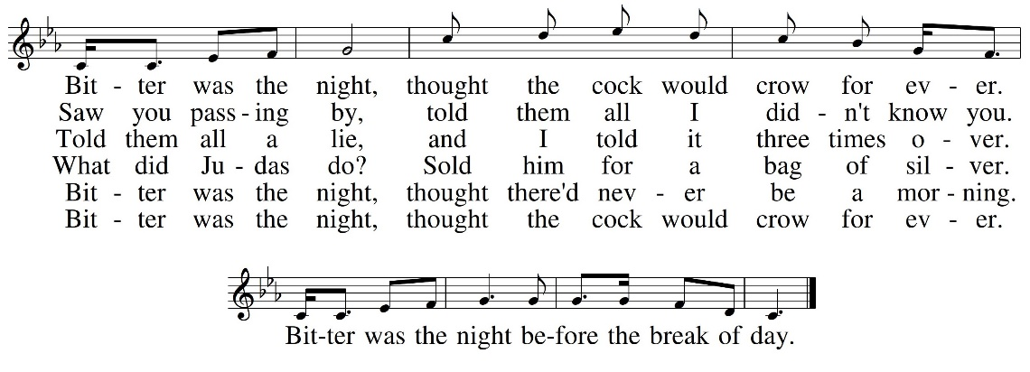

Reflection

The Lord’s Prayer
Silent Reflection

Sharing of the Peace and Departure

CCLI No., 11287624, 20371363

The church bulletins are presented to the glory of God,
and in loving memory of Muriel and Eric Hubley,
George and Susan Burns and Ray and Dorothy Hubley,
gift of their children and grandchildren,
Clay, Blair, Andy, Donette and families.

Deep Spirituality, Bold Discipleship, Daring Justice
The United Church of Canada is a community of hope, a vibrant and vital church with both purpose and vision. We live in a time of rapid change in religious life, great inequities between peoples, and collective harm to our earth community. Together, we strive towards repentance, repair, and right relations with all peoples and the planet. Living purposefully into this call and vision anticipates becoming the Beloved Community—the ever inbreaking, transforming, reconciling realm of God, today!

Vision Statement
As followers of Jesus Christ, Bridgewater United Church is a church family that values each person as equal and unique loving expressions of God with gifts and talents to share. People of all ages, gender, race, sexual orientation, gender identity, differing abilities, ethnic background, economic circumstance, and those experiencing other barriers that limit inclusion are welcome to fully participate in all our ministries.

Mission Statement
To create a vibrant community of followers of Jesus where everyone deeply knows they belong, are cared for, can grow spiritually and actively demonstrate our love in the world and towards one another.

Core Values
We value energetic engagement in our:
Spiritual Health
Generosity
Acceptance of all
Responsiveness to the world
Love for God, creation, self, and others

#APlaceWhereEveryoneBelongs
#ChooseLove

87 Hillcrest Street, Bridgewater, NS, B4V 1T2
Church Office Phone: (902) 543-4833
Ministers’ and Pastoral Care Private Church Phone: (902) 543-6854
Reverend Neil McEwen westsideunitedchurch@gmail.com (902) 523-5687
Reverend Hans van Nie hans@bridgewaterunited.ca (902) 277-4235
Church Office E-mail: info@bridgewaterunited.ca Website: www.bridgewaterunited.ca
Church Office Hours ~ Tuesday to Friday ~ 10:00am – 12:30pm
Be sure to like and share our Facebook and YouTube page!
Our Church is a Nut-Free and Scent-Free Church

