Bridgewater United Church
March 31st, 2024 Easter/Resurrection Sunday
Ministry Team: Reverend Neil McEwen and Reverend Hans van Nie
Organist and Pianist: Walter Delahunt

Audio Visual Technician: David Walker Sound Engineer: Ewart Morse

Greeter: Yvonne Hirtle Greeter: Carolyn MacKay

The asterisk (*) indicates the congregation may stand, as they are able.
The print in BOLD is where the congregation participates.

Prelude

Welcome and Announcements

*Chorus Video: “B-United”

Lighting of the Christ Candle and Inclusivity Candles

Invitation To Worship:
Christ is risen!
Christ is risen indeed!
This day God calls us to be people of new life.
Amen! Hallelujah!
Let us live out the power of Christ raised from the dead.
Christ is risen.
Christ is risen indeed!

Opening Prayer: (unison)
Eternal God, who breathes life into dust
and brings new life out of death:
we are gathered as your Easter people,
raised up with Christ in resurrection hope.
Loving God, who offers us new life in Christ;
we thank you for this gift of your abundant grace.
May our whole lives express our grateful thanks;
we pray in the name of our risen Saviour. Amen.

*Hymn: “Jesus Christ Is Risen Today” (VU 155)

Your Generosity Matters: Easter Prayer from the Indigenous Church

Invitation to Offering

We offer our gifts of time, talents and treasures each day. Offering plates are located at the
entrance of the Sanctuary where you can place your donations as you arrive or as your leave.
The offering plates are not circulated among the congregation during our Service of Worship.
*Offertory Response: “Praise God from Whom All Blessings Flow” (VU 541)

*Prayer of Dedication: (unison)
God of Easter, you are the holy source of resurrection.
You are the dancing spirit of life.
We offer our gifts in gratitude for hope returned,
for the mystery of your grace, and for the promise of new life. Amen.

Learning Together: A Time for All Ages

The Lord’s Prayer

*Hymn: “Christ Is Risen from the Dead” (VU 167a)

Epistle Scripture Reading: 1 Peter 2:1-7
Herein is guidance,
Thanks be to God.

Gospel Scripture Reading: Mark 16:1-8
Herein is good news,
Thanks be to God.

Sermon: “The Cornerstone”

*Hymn: “Christ Is Alive” (VU 158)

Sacrament of Holy Communion (found on yellow insert)

*Hymn: “Thine Is the Glory” (VU 173)

*Extinguishing The Candles

*Commissioning and Benediction

Postlude
CCLI No., 11287624, 20371363

The church bulletins are presented to the glory of God,
and in loving memory of parents, Ethel and Vincent “Pat” Veinotte
and brother, David, a gift of Dawn, Brian, Todd, Jayne and Sophie.

Deep Spirituality, Bold Discipleship, Daring Justice
The United Church of Canada is a community of hope, a vibrant and vital church with both purpose and vision. We live in a time of rapid change in religious life, great inequities between peoples, and collective harm to our earth community. Together, we strive towards repentance, repair, and right relations with all peoples and the planet. Living purposefully into this call and vision anticipates becoming the Beloved Community—the ever inbreaking, transforming, reconciling realm of God, today!

Vision Statement
As followers of Jesus Christ, Bridgewater United Church is a church family that values each person as equal and unique loving expressions of God with gifts and talents to share. People of all ages, gender, race, sexual orientation, gender identity, differing abilities, ethnic background, economic circumstance, and those experiencing other barriers that limit inclusion are welcome to fully participate in all our ministries.

Mission Statement
To create a vibrant community of followers of Jesus where everyone deeply knows they belong, are cared for, can grow spiritually and actively demonstrate our love in the world and towards one another.

Core Values
We value energetic engagement in our:
Spiritual Health
Generosity
Acceptance of all
Responsiveness to the world
Love for God, creation, self, and others

#APlaceWhereEveryoneBelongs
#ChooseLove

87 Hillcrest Street, Bridgewater, NS, B4V 1T2
Church Office Phone: (902) 543-4833
Ministers’ and Pastoral Care Private Church Phone: (902) 543-6854
Reverend Neil McEwen westsideunitedchurch@gmail.com (902) 523-5687
Reverend Hans van Nie hans@bridgewaterunited.ca (902) 277-4235
Church Office E-mail: info@bridgewaterunited.ca Website: www.bridgewaterunited.ca
Church Office Hours ~ Tuesday to Friday ~ 10:00am – 12:30pm
Be sure to like and share our Facebook and YouTube page!
Our Church is a Nut-Free and Scent-Free Church

Easter/Resurrection Sunday
Sacrament of Holy Communion

Confession:

Come to us, Risen One, like fresh water,
softening the soil of a parched and weary land.
Hurts and disappointments harden our hearts,
frustrations and failures dry us out.
Come to us, Risen One, with life-giving power.
Free us from resentment, reluctance, and reserve.
Remind us that in your embrace, we are free…

~ silent confession ~

Kyrie: Marty Haugen VU 932
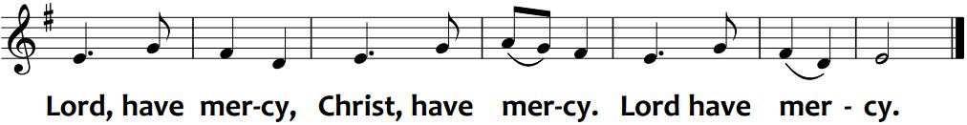

Assurance:

As life bursts forth from the darkness of earth’s soil,
so Christ bursts the darkness of despair.
Sadness ends, hope abounds, joy springs forth.
Strength is found to face every tomorrow;
God’s wholeness brings healing to all.
The world and all that is in it
glows with the glory of God.

Invitation: (based on Luke 24:13-16, 28:31,35)

On the day of resurrection, Jesus appeared to two disciples,
on the road to Emmaus, but they did not recognize him.
Later while they were at the table, Jesus took bread,
blessed and broke it, and gave it to them.
Then their eyes were opened, and they knew the Risen Christ.
May Christ’s presence be made known to us,
in the breaking of bread.

The Great Thanksgiving:

God is with us.
We are not alone.
Let us open our hearts to God.
We open our hearts to God and to one another.
Let us give thanks to God!
It is good to give our thanks and praise.

Hallelujah, thanks and praise, ever-living God,
worker of wonders, maker of miracles,
author of all life and giver of life eternal!
Out of chaos and fear, you bring beauty and hope.
Out of despair and death, you bring new life.
And so, with the risen Christ, who makes all things new
through the energy of resurrection,
we join in the song of a new day, to sing your praise:

Sanctus, Benedictus: Marty Haugen VU 932

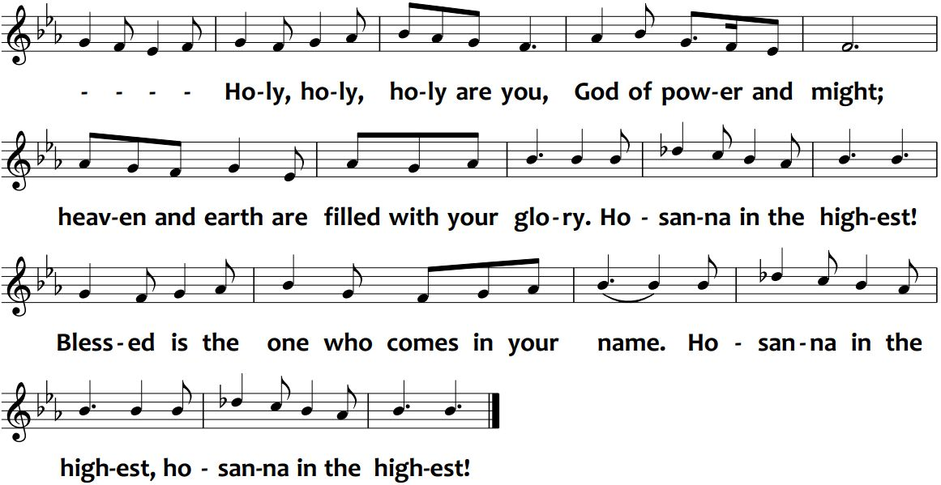

Words of Institution:

We do what Jesus did the night before he died.
He took bread, gave thanks, broke the bread,
and gave it to his friends, and said,
“Take, eat; remember me.”
Then he took the cup, and said,
“Take, drink; remember me.”
Through this loaf and cup, Christ is present within us.
In word and deed, Jesus lives among us.
God of love, we give thanks and we remember:
We remember Jesus,
faithful friend and living hope:
attesting truth before the powers;
seeking the forgotten and oppressed;
placing the prodigal and the righteous
at the one feast of forgiveness.
We remember Jesus, risen and eternal One,
Christ who comes to meet us.

Memorial Acclamation: Marty Haugen VU 933
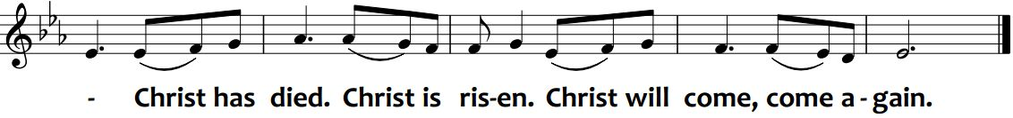

Prayer for the Holy Spirit:

Holy God, pour your Spirit upon us,
that we may know Christ in the breaking of bread;
that in word and deed, we may be channels of your love,
your peace and justice, in our lives and in the world.
Come, Holy Spirit, transform our lives, renew the world,
until justice rolls down like waters,
and righteousness like an ever-flowing stream.

Doxology:

Praise be to God, Source of Love!
Praise be to Christ, Love incarnate!
Praise be to the Spirit, Love’s power!
Praise be to God!

The bread is broken.

This broken bread is our communion in the body of Christ.
Thanks be to God for the bread of life.

The cup is filled.

This cup poured out is our communion in the blood of Christ.
Thanks be to God for the cup of blessing.
Great Amen: Marty Haugen VU 933

Sharing the Loaf and Cup:

Please come to the table via the centre aisle.
Receive a paper cup containing a grape and piece of bread.
Take the elements with you, back to your seat.
Return to your seat via the side aisles.
We will consume the elements together at the Minister’s direction.

Prayer after Communion:

For the bread we have eaten,
for the wine we have tasted,
for the life we have received, we thank you God.
Grant that what we have been given here,
may so put its mark on us
that it may remain always in our hearts.
Grant that we may grow in love and understanding,
living abundant life through the Risen Christ. Amen.

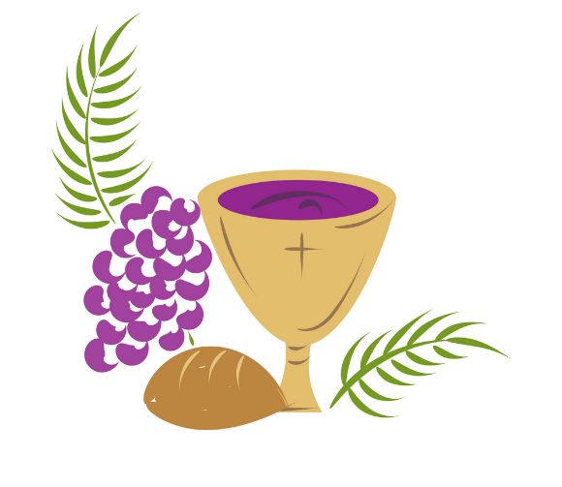

Broadview Subscription
Broadview is an independent Canadian magazine featuring award-winning coverage of spirituality, justice and ethical living. Through their compelling stories and engaging images, Broadview challenges and inspires readers seeking to live a purpose-filled life. Each annual subscription is $30.00, with cheques made out to Bridgewater United, and all subscriptions must be submitted to the Church Office by March 31st.

Church Office Closed
The Church Office will be closed on April 2nd. For Pastoral Care Concerns, please phone (902) 543-6854. Church emails and voicemails will be checked on April 3rd.

Musique Royale Presents Meredith and Daniel
On April 6th at 2:00pm, Musique Royale invites you to a Cookie Concert at the Lunenburg School of the Arts, featuring contemporary dancer, Meredith Kalaman and composer, Daniel MacNeil, where we will experience a new work which fuses their creative energies in dance and music. MacNeil combines acoustic instruments, electronics and musical elements from all around the world for the creation of a real-time soundscape which is interactive with the reflective looping movements of Kalaman, exploring the expansion of time in relation to MacNeil’s original sound score. Together, they weave a rich and textured journey through sound and sight. Tickets are $5 at the door and free for children four and under!

Musique Royale Presents Hallelujah & Trumpets!
Musique Royale welcomes back Ensemble ArtChoral and Ensemble Caprice led by the irrepressible Matthias Maute for "Hallelujah and Trumpets!" This is a performance highlighting the splendour of George Frideric Handel's music. Join us to hear the exuberant and dynamic combined forces of these two ensembles on April 12th at 7:30 pm at St John's Anglican Church in Lunenburg (64 Townsend St.) The concert includes a pre-concert rehearsal at 7:00pm where the audience is invited to sing with director Matthias Maute! Tickets are $35 at the door, $30 in advance, and $10 for students. Visit www.musiqueroyale.com for more information!

Youth@Region
Youth@Region is a place of community and faith where United Church youth, between grade 6 and grade 12, meet from across Nova Scotia and Bermuda. It takes place during the Annual Meeting of Bermuda-Nova Scotia Regional Council (BNS), held this year from May 10th – 12th, at Dalhousie Agricultural Campus (Truro, NS.) They provide a place for youth to explore their faith and to learn more about the United Church of Canada while sharing in music, worship and fun in a spirit-filled community. The Faith Formation Committee will help assist with registration cost.

Sherbrooke Lake Camp 60th Anniversary Homecoming
Join Sherbrooke Lake Camp from August 2nd – 4th, as they host a big homecoming event to welcome folks back to Sherbrooke Lake Camp in celebration of 60 years of friendship, faith and fun! This weekend event will offer some of your Sherbrooke Lake favourites, from campfires to candle lighting! This is a family-friendly event.
Flowers have been placed in the Sanctuary, in loving memory of:

My parents, Clifford and Lorna Blades, gift of daughter, Diane Patten.

Ernie Bolivar, a gift of his family.

BUD Online Ministries
We continue to provide Online Video Worship Services on the 2nd and 4th Sundays, and Online Audio Podcast Messages on the 1st, 3rd and 5th Sundays. The Audio Podcasts are Scripture and Reflections from our B-United On-Site Worship Services.

Why Volunteer?
Here at B-United, we are always looking for volunteers during our Worship Service as well as on Committees/Ministries of Bridgewater United Church. Taking the first step to see what volunteering is all about, is the toughest part, but in the end, the rewards are endless. Not only do you get to use your own gifts to help others, but you may also build new skills as you go along. Volunteering allows you to meet new people, and build a strong fellowship within your Church Community. Take some time and think about the various volunteer portions of our Worship Services; Greeter, Sound Engineer, Audio Visual Engineer, Scripture Reader, Offering Counter and Sunday School Volunteer. All of these are important to the growth of our church, so think where your talents and gifts can be offered, and speak to our Ministry Team today or reach out to us by email at info@bridgewaterunited.ca.

Send A Kid To Camp
Wouldn’t it be wonderful if every child could have an opportunity to go to a United Church Camp? Kids need camp more today than ever before. It's a place for kids to be themselves, to learn new skills, unplug, develop independence and meet friends. To attend a week of camp, it costs $435.00. Please consider donating to “Send a Child to Camp,” as all funds raised will help youth of B-United attend camp this summer.

B-United Supports our Local Food Bank
Monetary donations and donations of non-perishable food items are always appreciated throughout the month. For March, there is a request for Canned Fruit, Canned Soup, Canned Peas, Boxed Cereal, and Elbow Macaroni. Thank you.

A Message from your Envelope Steward
With your February letter/tax receipt, you will find an important form (pink paper) to be filled out by all congregational families to help the Church Office update details in our PowerChurch files. Please check off the information you are comfortable with the Church Office releasing to Committees/Ministries of Bridgewater United. This allows us to continue to respect the privacy of all of our congregational members.

Minute for Mindfulness
“There will come a time when you believe everything is finished;
that will be the beginning.”
~ Louis L'Amour
“For where your treasure is, there your heart will be also.”
~ Matthew 6:21

Prayerfully decide what you will give each year to your Church and divide that amount by twelve. Contributions help our Church’s Ministry, with a dependable flow of contributions, to increase our overall financial stability. Church envelopes allow your Church Givings to be tallied into a year-end income tax receipt. Your regular givings supports the local ministry of our congregation. With a Church Envelope you can designate where you would like your givings to be distributed.

Local Expenses Designation helps with the overall daily upkeep of the building, such as electricity, heating costs, insurance, as well as personnel expenses.

Mission and Service Designation is forwarded to The United Church of Canada to be deposited to their Mission and Service Fund which is used for many wonderful Outreach aspects that The United Church of Canada is a part of such as helping people overcome poverty, train new ministers and Mission and Service Gifts support vibrant and vital ministries for the healing of the world.

Building Fund Designation helps with repairs/upgrades that need to be undertaken by B-United, to make sure our building is safe for all that use it.

Food Bank Designation helps The Bridgewater Inter-Church Food Bank, which provides help to those who are in need. We encourage our members to bring in non-perishable food bank items to be placed in Brother Lawrence’s Wheelbarrow in the Narthex throughout the month or you can place a monetary donation in the Offering Plate. This can be specified on your Church Envelope.

PAR is a monthly pre-authorized bank withdrawal by Bridgewater United Church directly, that can be increased or decreased five business days before the end of the month. PAR is not only convenient, but it ensures regular monthly givings to help your Church’s Ministry even when you are away.

Sunday School Local Designation helps with obtaining supplies for weekly curriculum, snack items, yearly curriculum lessons and events the youth will be taking part in and much more. It provides for the daily upkeep of Sunday School.

Sunday School Mission and Service Designation is forwarded to The United Church of Canada to be deposited to their Mission and Service Fund which is used for many wonderful Outreach aspects of The United Church of Canada.

e-Transfers are now accepted by Bridgewater United Church. Add info@bridgewaterunited.ca as a payee, and you can submit your donation that way.

Any questions, please do not hesitate to contact Tracy Rafuse, Envelope Steward, at (902) 543-4833 or by email at info@bridgewaterunited.ca. Thank you.

We are now given an opportunity to be a blessing to others.
Through our PAR commitments, through our money, and through our time and talents,
we now return to God, so that we might be a part of God’s Love and God’s Mission.

Treasurers’ Report to the Church Congregation
for the Two-Month Period ending February 29, 2024

Receipts

Total Local Receipts $ 22,296.00
Trust Receipts
Mission and Service $ 1,755.00
Scouting Sunday Funds $ 245.00
Food Bank Receipts $ 615.00
Faith Formation Funds $ 10.00
Misc. Trust Receipts $
Building Use Receipts $ 10,275.00
Radio Broadcast Service $ 1,450.00
Fundraising Receipts $
UCW Donation $
Misc. Receipts $ 40.00
Total Receipts (Note 1) $ 36,686.00

Disbursements
Total Trust Disbursements $ 2,370.00
West Side/B-United Agreement $ 6,985.00
Total Personnel Expense $ 19,391.00
Total Office & Admin Expense $ 3,981.00
Heating Fuel $ 10,824.00
Lights, Water & Sewer $ 1,955.00
Snow Removal & Salting $ 7,926.00
Insurance $ 2,334.00
Floor Maintenance $
Other Premises Expenses $ 451.00
UCC Assessment $
Other Misc. Expenses $ 655.00
Total Disbursements (Note 1) $ 56,872.00

Operating Deficit at End of Period $ 20,186.00

Bank and GIC Balance: $ 117,662.74

Note 1:
Total Receipts and Disbursements does not include Building Fund Receipts or Disbursements, Memorials to Memorials and the B.U.C. Brigade Mission Fund Transactions. This report is a brief summary of the February 29, 2024 Actual Sage Accounting Income Statement.

Respectfully submitted,
Blake Hirtle; Bridgewater United Church Treasurer
March 22, 2024
B-United PAR Authorization Form
(Pre-Authorized Remittance)
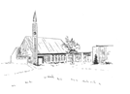
B-United PAR Authorization
Donor Name(s): _________________________________________________
Address: _______________________________________________________
______________________________________________________________
Phone: ________________________________________________________
Email: ________________________________________________________
Envelope #: ______________ Monthly Gift Amount: _________________

My Monthly Gift of $ ________ will be designated to benefit monthly:
(Please specify amounts designated to which Church Fund)

Local: $____ Mission and Service: $____ Building $____ Food Bank: $____

I/we authorize, Bridgewater United Church, to debit my/our bank account on one of the following dates, 1st, 20^{th,} or Month-End of every month, starting on ________________, 20___.

I/we may change the amount of my/our contribution five days before month-end, by contacting the Envelope Steward with this adjustment. I/we have certain recourse rights if any debit does not comply with this agreement. I/we waive my right to receive pre-notification of the amount of pre-authorized remittance (PAR) and agree that I do not require advance notice of the amount of PAR before the debit is processed monthly.
I/we acknowledge that I/we have read and understood all the provisions contained in the terms and conditions of the pre-authorized payment authorization and that I/we have received a copy.
Please attach a VOID cheque.
Signed: __________________________________ Dated: ________________
Signed: __________________________________ Dated: ________________

